Marks : 9.5
Comment can be added to increase readability

library(readxl)
library(dplyr)
library(ggplot2)
library(cowplot)

#reading excel file
stuper = read_excel("/Users/shivam/Desktop/pds_midterm/StudentsPerformance.xlsx")

View(stuper)
head(stuper)
tail(stuper)
nrow(stuper)
str(stuper)
print(stuper)

Function 1 :
summary(stuper)

Insight : There are total 1000 rows. The mean of math_score, writing_score and reading_score are 66.09, 68.05 and 69.17 respectively. Also, we can find min, max and median values below for different scores.

gender group math_score writing_score
Length:1000 Length:1000 Min. : 0.00 Min. : 10.00
Class :character Class :character 1st Qu.: 57.00 1st Qu.: 57.75
Mode :character Mode :character Median : 66.00 Median : 69.00
Mean : 66.09 Mean : 68.05
3rd Qu.: 77.00 3rd Qu.: 79.00
Max. :100.00 Max. :100.00

Reading_score
Min. : 17.00
1st Qu.: 59.00
Median : 70.00
Mean : 69.17
3rd Qu.: 79.00
Max. : 100.00

Function 2 :
grp_count = stuper %>% count(group)
grp_count

Insight : Group A have least number of students while Group C have most number of Students.
group n
1 group A 89
2 group B 190
3 group C 319
4 group D 262
5 group E 140

Function 3 :
new_stuper = mutate(stuper,average_score=round((math_score+reading_score+writing_score)/3))
head(new_stuper)
summary(new_stuper)

Insight : Here, we are adding new column to the table and we can find summary for it.

average_score
Min. : 9.00
1st Qu.: 58.00
Median : 68.00
Mean : 67.76
3rd Qu.: 78.00
Max. :100.00

Function 4 :

agg_math_score = aggregate(new_stuper$math_score, list(stuper$group), FUN=mean)
colnames(agg_math_score) <- c('group','avg_math_score')
agg_math_score

agg_reading_score = aggregate(new_stuper$reading_score, list(stuper$group), FUN=mean)
colnames(agg_reading_score) <- c('group','avg_reading_score')
agg_reading_score

agg_writing_score = aggregate(new_stuper$writing_score, list(stuper$group), FUN=mean)
colnames(agg_writing_score) <- c('group','avg_writing_score')
agg_writing_score

agg_average_score = aggregate(new_stuper$average_score, list(stuper$group), FUN=mean)
colnames(agg_average_score) <- c('group','avg_student_performance')
agg_average_score

dev.off(dev.list()["RStudioGD"])

p1 = ggplot(agg_math_score, aes(x=group, y=avg_math_score, fill=group)) + geom_bar(stat="identity") +
labs(x="Groups", y="Average_Math_Score")
p1

p2 = ggplot(agg_reading_score, aes(x=group, y=avg_reading_score,fill=group)) + geom_bar(stat="identity") +
labs(x="Groups", y="Average_Reading_Score")
p2

p3 = ggplot(agg_writing_score, aes(x=group, y=avg_writing_score,fill=group)) + geom_bar(stat="identity") +
labs(x="Groups", y="Average_Writing_Score")
p3

p4 = ggplot(agg_average_score, aes(x=group, y=avg_student_performance,fill=group)) + geom_bar(stat="identity") +
labs(x="Groups", y="Average_Student_Performance")
p4

plot_grid(p1,p2,p3,p4,labels="AUTO")

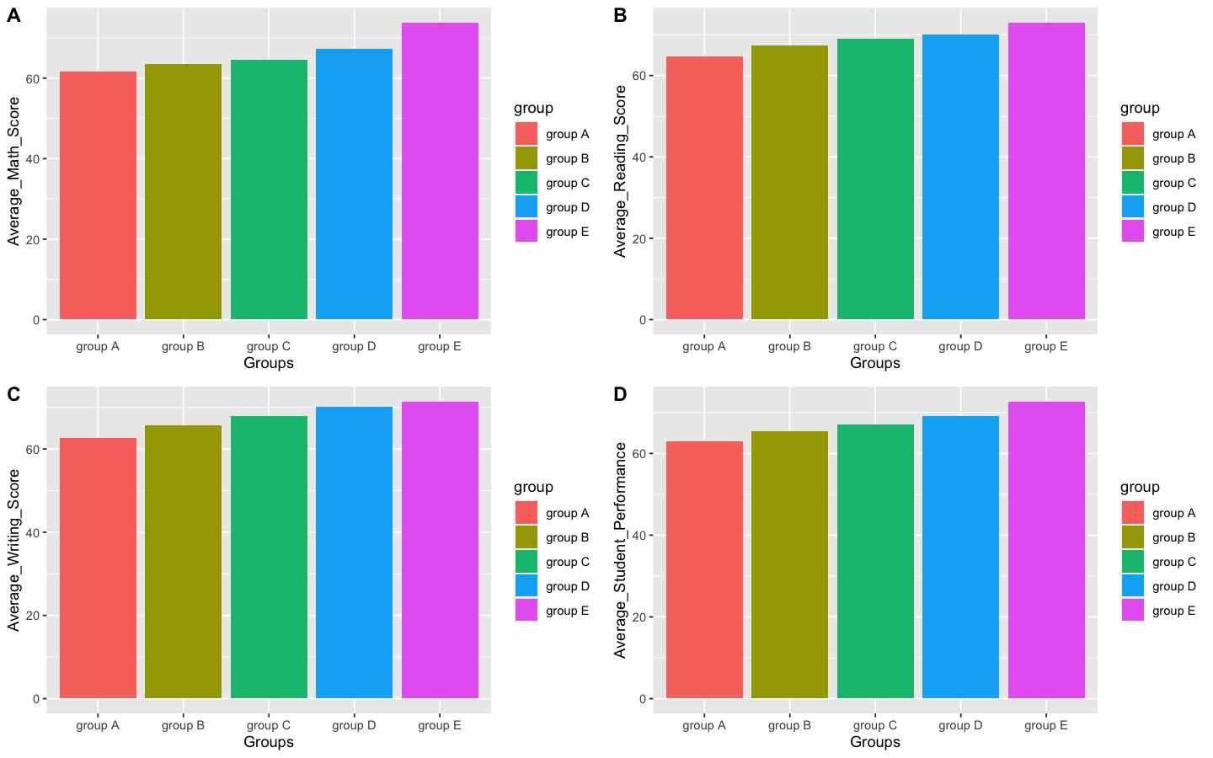

Function 5 :

grp2_avg = stuper %>% group_by(group,gender) %>%
summarise(avg_math = mean(math_score))
grp2_avg

ggplot(grp2_avg,(aes(x=group,y=avg_math,fill=gender))) +
geom_bar(stat = "identity",position = "dodge")

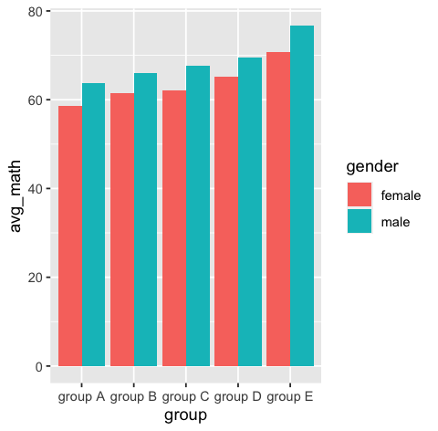

Function 6 :

total_stuper = mutate(stuper,total_score = (math_score+reading_score+writing_score))
total_stuper$total_score
head(total_stuper)

grp3_total = total_stuper %>% group_by(group,gender) %>%
summarise(sum_total = sum(total_score))
grp3_total

ggplot(grp3_total,(aes(x=group,y=sum_total,fill=gender))) +
geom_bar(stat = "identity",position = "dodge")

total_box=ggplot(total_stuper, mapping=aes(x=group, y=total_score))+geom_boxplot()
total_box

total_box=ggplot(total_stuper, mapping=aes(x=group, y=total_score, fill=gender))+geom_boxplot()
total_box

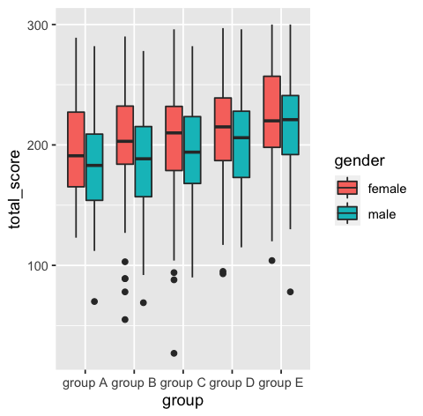

#Work Done by Shivam Tayal(22020845029)

